Catholic Social Teaching
SOLIDARITY
Reference Handout for Presentation Attendees
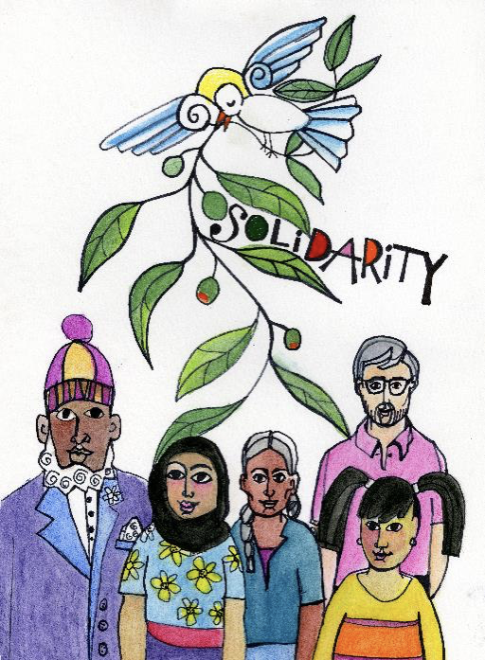
This packet compiles the materials from the August 2025 Solidarity presentation, plus one supplemental document not shown in the original slides (see appendix).

1. Solidarity — USCCB Definition

We are one human family whatever our national, racial, ethnic, economic, and ideological differences. We are our brothers' and sisters' keepers, wherever they may be. Loving our neighbor has global dimensions in a shrinking world. At the core of the virtue of solidarity is the pursuit of justice and peace. Pope Paul VI taught that “if you want peace, work for justice.” The Gospel calls us to be peacemakers. Our love for all our sisters and brothers demands that we promote peace in a world surrounded by violence and conflict.

Scripture
- Genesis 12:1–3 — God blessed Israel so that all nations would be blessed through it.
- Psalm 72 — Living in right relationship with others brings peace.
- Psalm 122 — Peace be with you! For the sake of the Lord, I will seek your good.
- Zechariah 8:16 — These are the things you should do: speak truth, judge well, make peace.
- Matthew 5:9 — Blessed are the peacemakers; they will be called children of God.
- Matthew 5:21–24 — Be reconciled to one another before coming to the altar.
- Romans 13:8–10 — Living rightly means to love one another.
- 1 Corinthians 12:12–26 — If one member of Christ's body suffers, all suffer; if one member is honored, all rejoice.
- Colossians 3:9–17 — Above all, clothe yourself with love and let the peace of Christ reign in your hearts.
- 1 John 3:16–18 — The love of God in us is witnessed to by our willingness to lay down our lives for others as Christ did for us.

2. Summary Statement of Catholic Social Teaching

In Catholic social teaching, solidarity means a firm and persevering commitment to the common good — recognizing that we are one human family and responsible for one another, especially the poor and vulnerable.

Core Meaning
- One human family: Solidarity affirms that all people share equal dignity regardless of nationality, race, or economic status.
- Moral responsibility: It calls each person to care for others, near or far, because “we are all really responsible for all” (St. John Paul II).
- Commitment to justice and peace: Solidarity requires addressing structural causes of poverty, inequality, and conflict.

Scriptural Foundations
- Genesis 12:3 — God blesses Israel so all nations may be blessed.
- Matthew 5:9 — “Blessed are the peacemakers.”
- 1 Corinthians 12:26 — If one member suffers, all suffer together.

Practical Implications
- Advocating for the poor, marginalized, and vulnerable.
- Promoting peace and reconciliation.
- Supporting policies that uphold human dignity and the common good.

As a Virtue and Social Principle
- A moral virtue: a determination to work for the good of all.
- A social principle: a guide for shaping institutions and laws toward justice.
Solidarity ultimately expresses the Church's conviction that authentic human flourishing is possible only when all people are cared for and included in the pursuit of justice and peace.

3. How Do We Exercise Solidarity as We Work to Build the Kingdom?

- Recognize your own social identity. What advantages and disadvantages come with that identity?
- Actively reject stereotypes through ongoing self-reflection and intentional practice.
- Seek out diverse perspectives. People, ideas, or practices that may initially seem unfamiliar, confusing, or unreasonable should be approached as opportunities for thoughtful study and continued learning. Numerous resources can support this process, including books, podcasts, reliable digital and electronic sources, travel, and conversation — for example, engaging with the Seeing White podcast series and examining what the Church teaches, as well as what it does not explicitly address.
- Engage in activism by practicing the corporal works of mercy and what may be called the corporal works of justice — voting, attending rallies, sharing constructive social media posts, contributing time, talent, and treasure, going to court, and wearing buttons or T-shirts that invite dialogue rather than condemnation.

4. Questions for Discussion

- Do you think that the synodal process begun by Pope Francis and affirmed by Pope Leo offers an opportunity to promote CST's principle of solidarity? How?
- Do we need to prioritize issues/goals of Catholic Social Teaching? Is it a mistake to do so or not do so?
- How do we African American Catholics, in particular, deal with brothers and sisters who are adamantly or functionally opposed to CST and the notion of Solidarity in the public square and in the life of the Church?
- There is clear danger in individuals and the Church choosing to be either “chaplains of the empire — however empire is described” or “prophets of the resistance, of the kingdom.” At this moment in our country/world, is it possible to be truly prophetic and not be seen as partisan?

NEW MATERIAL — NOT SHOWN IN THE ORIGINAL PRESENTATION SLIDES

Appendix: Pastoral Letter — Response to a Banner Inquiry (2020)
This letter is included as background reading, not as part of the formal CST/Solidarity teaching outline above. It is a pastor's personal response to a parishioner's letter concerning a Black Lives Matter banner displayed at Resurrection Catholic Missions. Personal email addresses have been redacted; names are retained as they appear in the original correspondence.
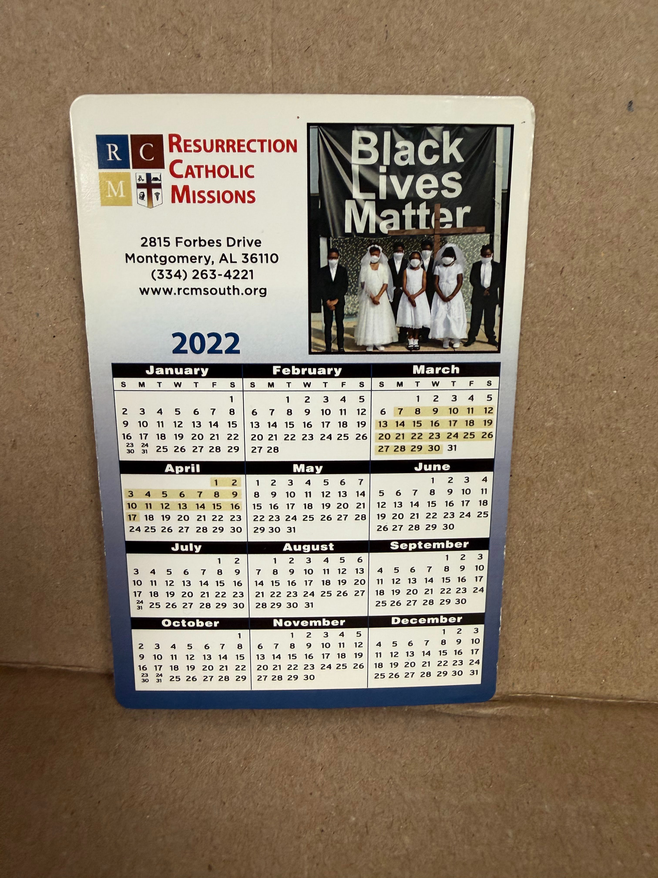
The banner referenced in the correspondence below (Resurrection Catholic Missions, Montgomery, AL)

September 29, 2020 — Response to Mr. Rials
Dear Mr. Rials:
I appreciate your thoughtful and obviously prayerful letter. The compassion and openness to discussion it exemplifies are encouraging. I hope you find my response thoughtful and prayerful.
Let me share some critical background information about myself with you. I am 33 years a priest and have been a pastor here for 30 years. I taught high school at my religious order's all-male, very diverse school in Chicago for years before I returned to Resurrection, my home parish as servant leader. I grew up in the segregated South as it opened itself to integration. In their mid-eighties, my parents were active in the Bus Boycott and the Civil Rights struggle. I graduated from St Jude High School, a 99% predominantly Black high school. I graduated from the University of Notre Dame with a degree in Sociology and Social Work. I entered the seminary with the Congregation of the Resurrection after doing social work for a year after graduation. I earned master's degrees in divinity, theology, and development from Aquinas Institute at St Louis University, Xavier University of Louisiana, and certification at the National Planned Giving Institute at the College of William and Mary. I served in leadership for my order for nearly 14 years. My entire priestly life, I have worked tirelessly to promote Catholicism in the African American community and social and racial justice in our country and our Church. Resurrection and I have partnered with leading human and civil rights organizations here in Montgomery, such as the Equal Justice Initiative and the Southern Poverty Law Center.
My immediate family is multiracial. I have a niece and a nephew who are biracial and direct descendants of Wendell Willkie, a distinguished Republican who ran against FDR. I have a much younger cousin who is being raised in Poland by my uncle's widow, a Polish native. I say all this to let you know just some of the history and experiences that form my faith, priestly ministry, and work as a citizen.
I have been a director and instructor at Xavier University of Louisiana's (XULA) Institute for Black Catholic Studies for almost a decade. In 2015, the Institute sponsored the first symposium for a Catholic and an HBCU — Historically Black College and University — on the Catholic Church and the Black Lives Matter Movement (BLM). Several theologians, religious leaders, sociologists, political and law enforcement leaders, journalists, and non-profit leaders shared how the Catholic Church might engage the BLM movement.
Given all this, you must understand the thought, prayer, and lifelong experience that compelled me and, in my view, should compel more Catholic institutions and Catholic people to proclaim UNEQUIVOCALLY Black Lives Matter!
The bishop of El Paso prayed the rosary as he held a BLM sign and received a congratulatory message from Pope Francis.
Since when does the Church have to agree with every principle or belief system of any organization or individuals with whom we work on matters that we agree? The Church ecumenically works with Christian and non-Christian traditions who certainly don't share all our dogmatic or social positions. We also work with governmental agencies and politicians we disagree with on many issues. BLM is no different. The Democratic and Republican parties both fall short of the gospel message. I utterly reject the notion that because the GOP gives lip service to being anti-abortion, that gives them a pass on being the epitome of the culture of death, as John Paul II called it. I detest abortion, and it is a real weakness of the Democratic party to be so uncritically in favor of choice, as they call it. But I fear the best we will be able to do is make abortion as rare as possible and expend our energy and our resources, economic, political and theological, to alleviate the social, economic, and cultural conditions that lead so many to see abortion as their only option.
Our Holy Father has been clear beyond obfuscation that you cannot be pro-life and countenance racism, xenophobia, militarism, misogyny, climate destruction, capital punishment, and oppression of the poor. When it is posited that abortion takes priority over all the other life issues, I reject that as not sound Catholic teaching, and those who propose it often do so from the stance of White privilege, where they are not adversely affected by death-dealing racism, sexism, environmental racism, oppression of the poor, lack of access to healthcare, etc.
Given the systemic racism still too rampant in this country and in our Church, we must say Black Lives Matter without qualifiers. White Lives have always mattered. Too often in our Church, our hierarchy talks about racism without saying anything challenging or anything that might “offend” white Catholics. There is no such reticence on matters of sexuality and family life. When I see pro-life banners alongside banners that God is pro-Black and pro-Brown and pro-Immigrant and pro-White and pro-Poor, then I will know we don't need BLM banners.
Please know my passion for this issue is as deep as my passion for our Church and this country. I am old enough to remember my parents voting freely for the first time. I remember white bishops confirming Black children without touching them. I remember burying great uncles who died in Vietnam when they couldn't vote in Alabama. My friend and hero, Bryan Stevenson, of EJI, has brilliantly chronicled just how much carnage the legacy of chattel slavery still inflicts on our country and Church.
This summer, I taught a course for XULA with three brilliant scholars on the Catholic Church and BLM. My colleagues were Dr. Diana Hayes, emerita professor of Church History at Georgetown, Dr. Brian Turner, a psychology professor at XULA, and Heather Malveaux, director of diversity at Loyola University of New Orleans. We discussed the concerns you raised and concluded that we must engage BLM and not fall prey to the false charges that have promoted violence and are antithetical to all that we stand for.
On Tue, Sep 29, 2020 at 12:44 PM, RCM INFO wrote:
This was in the RCM Info email inbox.
———— Forwarded message ————
From: James Rials <[email redacted]>
Date: Sun, Sep 27, 2020 at 2:38 PM
Subject: Banner.
To: <[email redacted]>
Cc: <[email redacted]>
Peace be with you Father Williams. I have given much thought and prayers for several days over the subject I wish to bring before you today. I will retire this December from the DoD and the Air Force Reserve at Keesler AFB in Biloxi, MS. I have lived my life in Grand Bay, AL and have been a member of St John's during this time. Upon retirement I will live full time in the Morning View area in Montgomery, which has been my second home five years now. I am a conservative white male, just for information. I am aware Resurrection Church is a predominantly Black member Catholic Church. As I was leaving Montgomery this past Tuesday evening and passed Resurrection, I was dismayed to see the Black Lives Matter banner very plainly displayed. Of course BLM — that is not in dispute in my mind at all. My concern is the BLM organization in no way reflects or represents our Catholic values of anti-abortion beliefs and support of a nuclear family. The fact that BLM members have been involved with the murder of law enforcement and citizens across the Nation is unacceptable, and the Church should have no association with the BLM organization. I ask of you to consider something or someway to make the banner more “Catholic,” such as BLM and so do the unborn, or BLM just as Jesus said all lives do. We both know our Country is deep in the midst of racial and societal divisions at this time and everyone is on edge. Please Father, I can't be the only one who has contacted you over this — I'm sure some are demanding the banner's removal; I'm not. I believe we can actually use this media to promote our Catholic faith to all who pass this location daily. I wish for you to know I have spoken with the Mobile Diocese, who actually suggested I contact you, Father. I pray you consider my suggestions, but I also realize I'm not one of your flock and that you are the Father of Resurrection Church. Again, peace be with you Father.
James Rials.

